**ENTRY PAGE DESIGN**

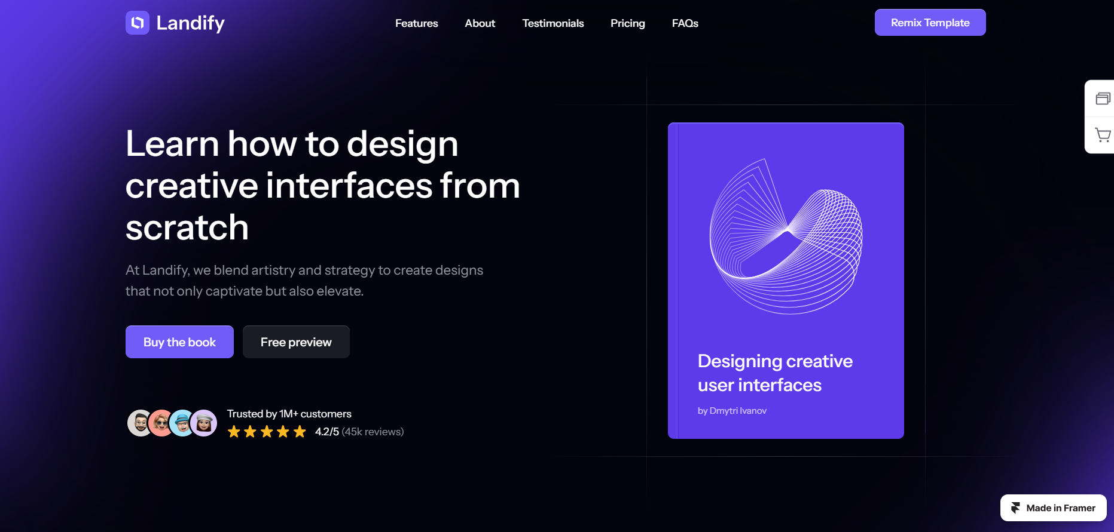

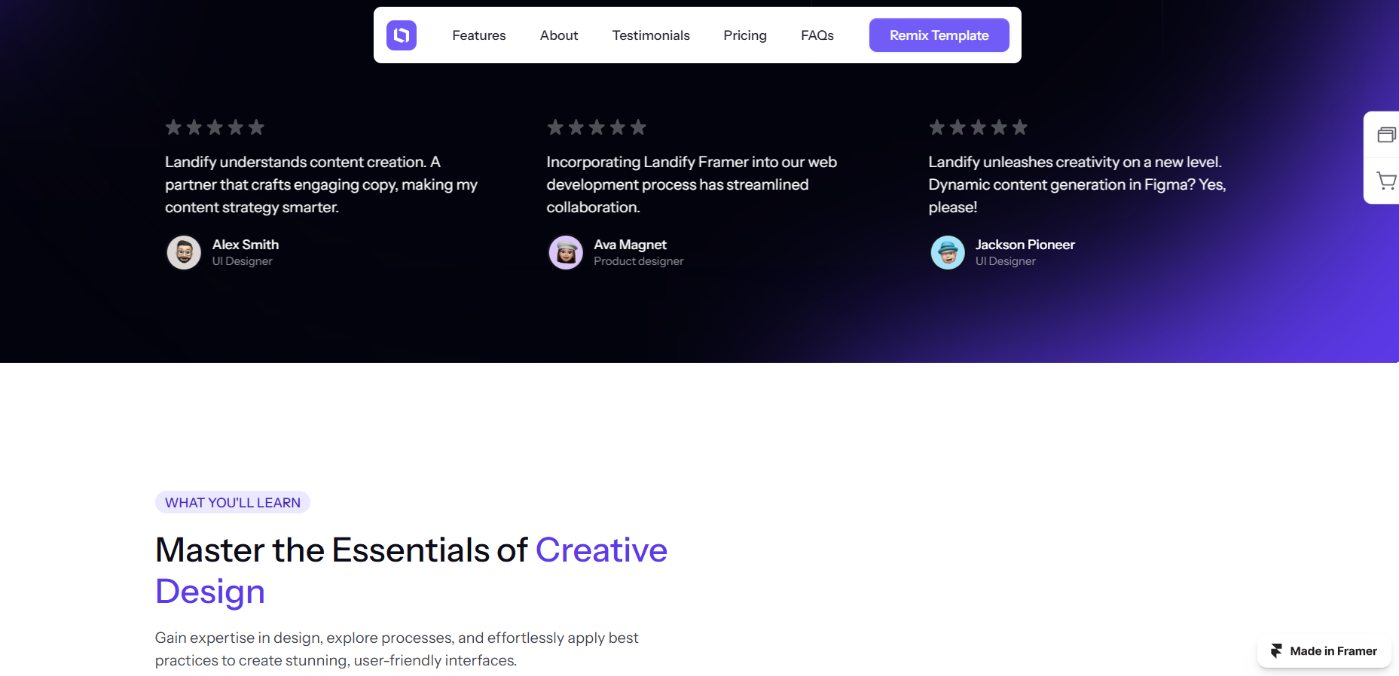

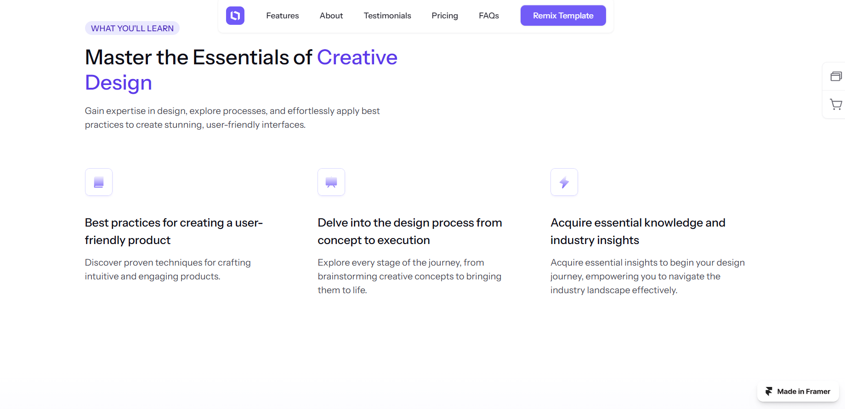

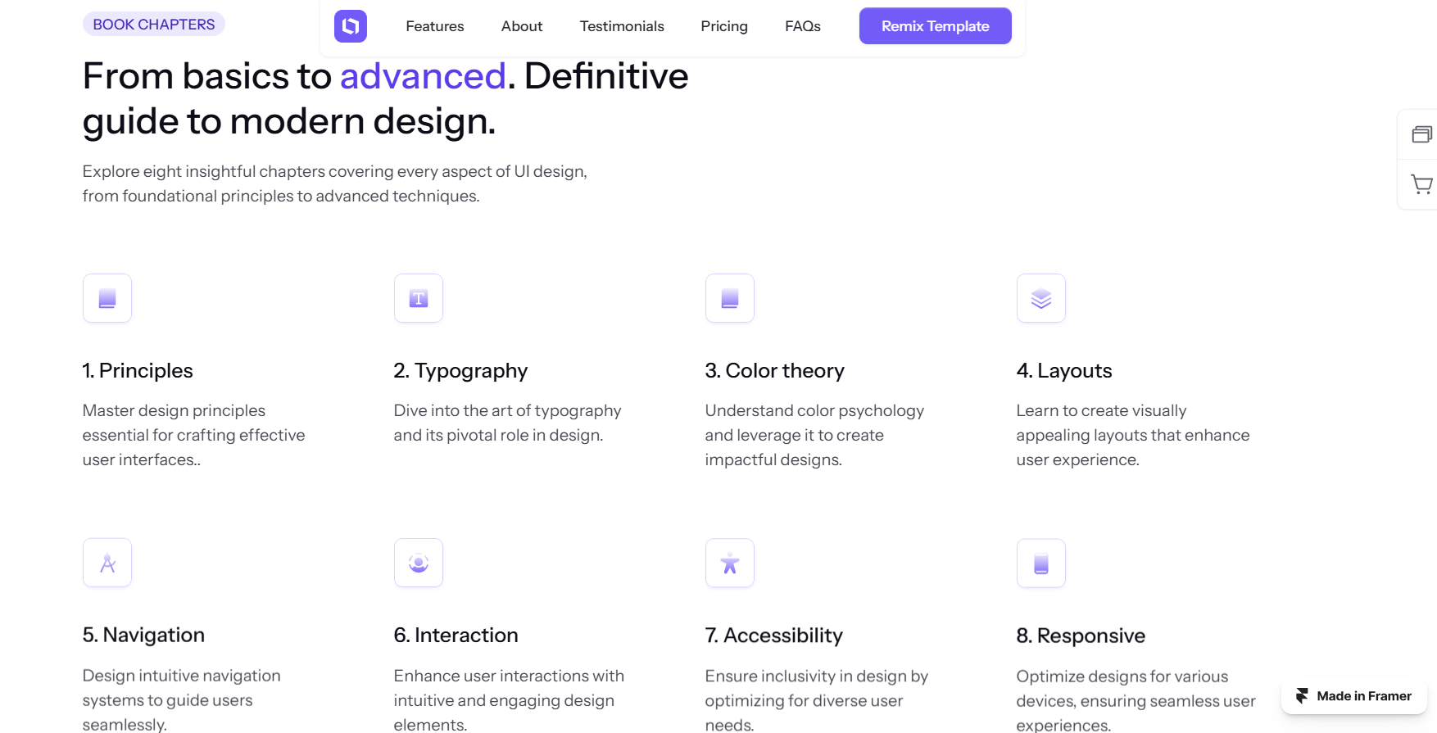

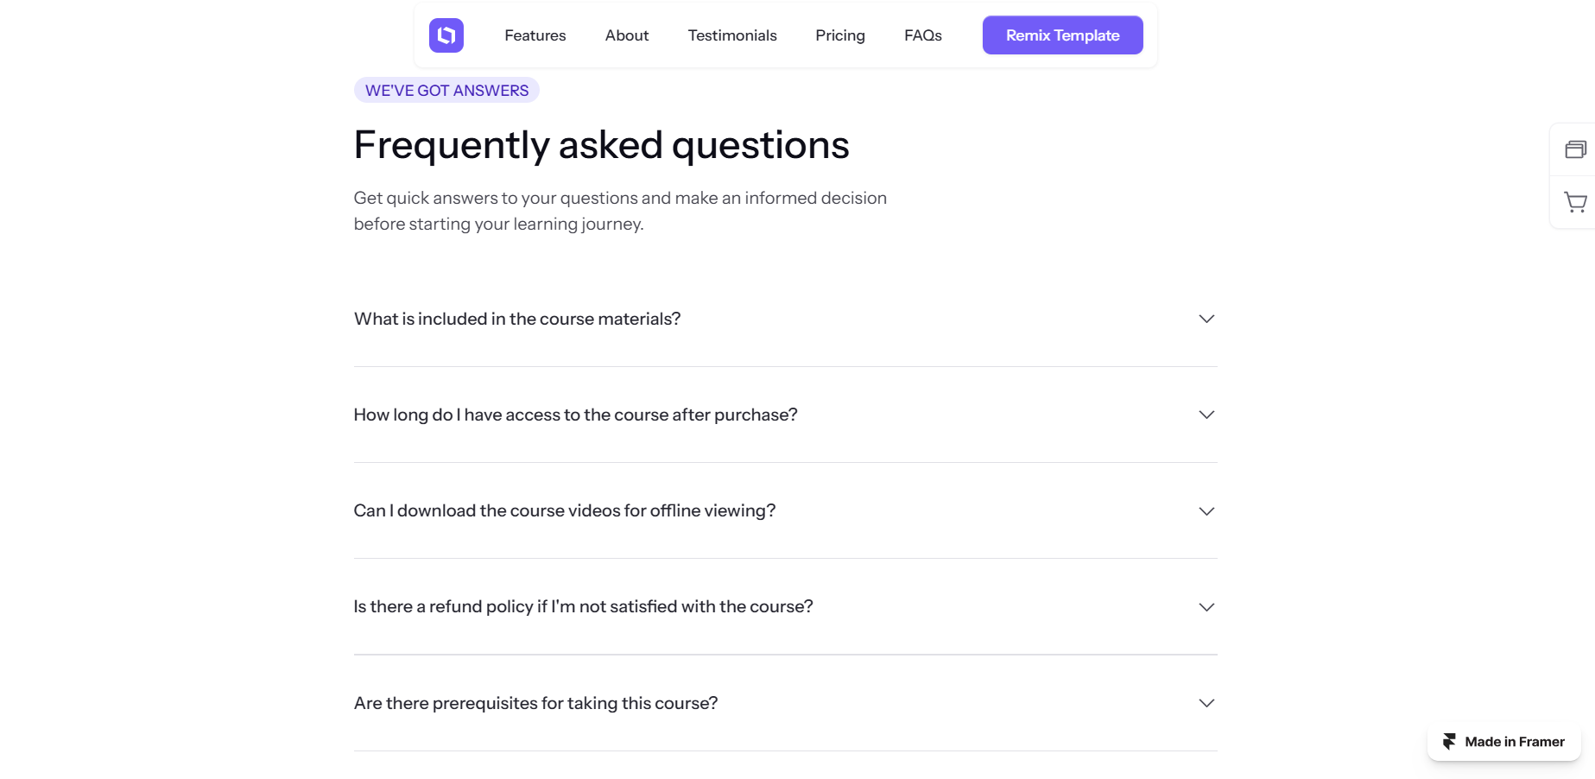



**LOGIN PAGE DESIGN**

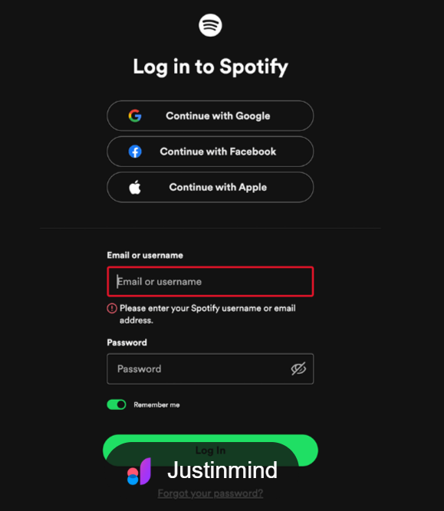

**SIGN-UP PAGE DESIGN**

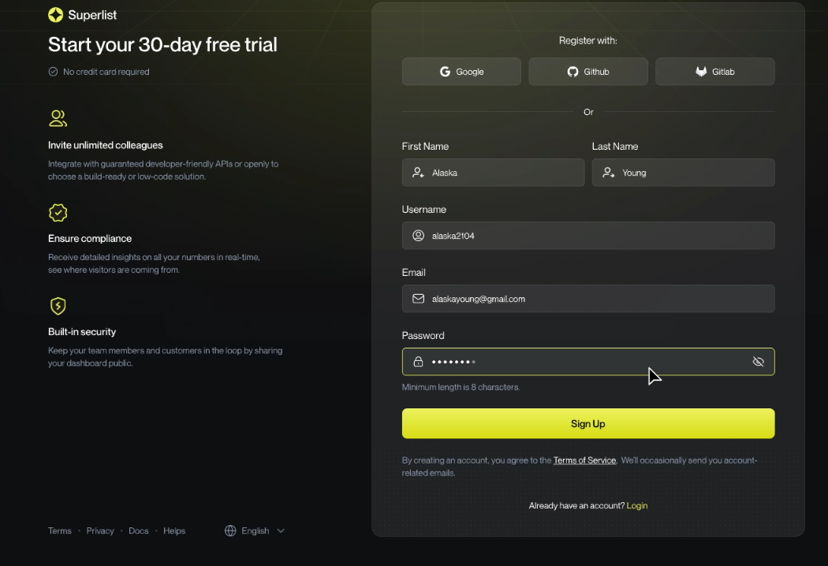

**MAIN PAGE DESIGN**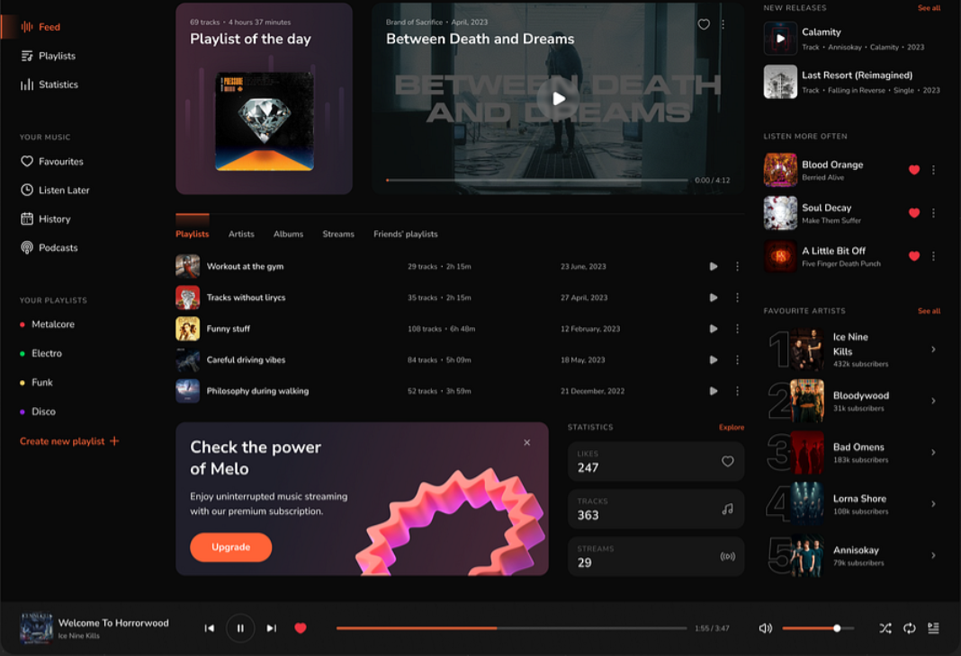

**NAVBAR DESIGN**



**DESIGN FOR PAGE CONTAINING TRAACKS , PLAYLIST ,ALBUM , ARTIST , TOP GLOBAL , TOP 50 , TOP VIRAL , TOP USA**

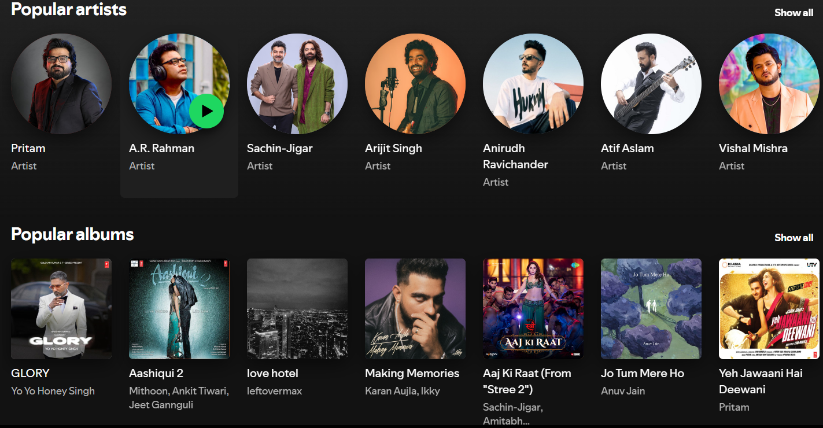

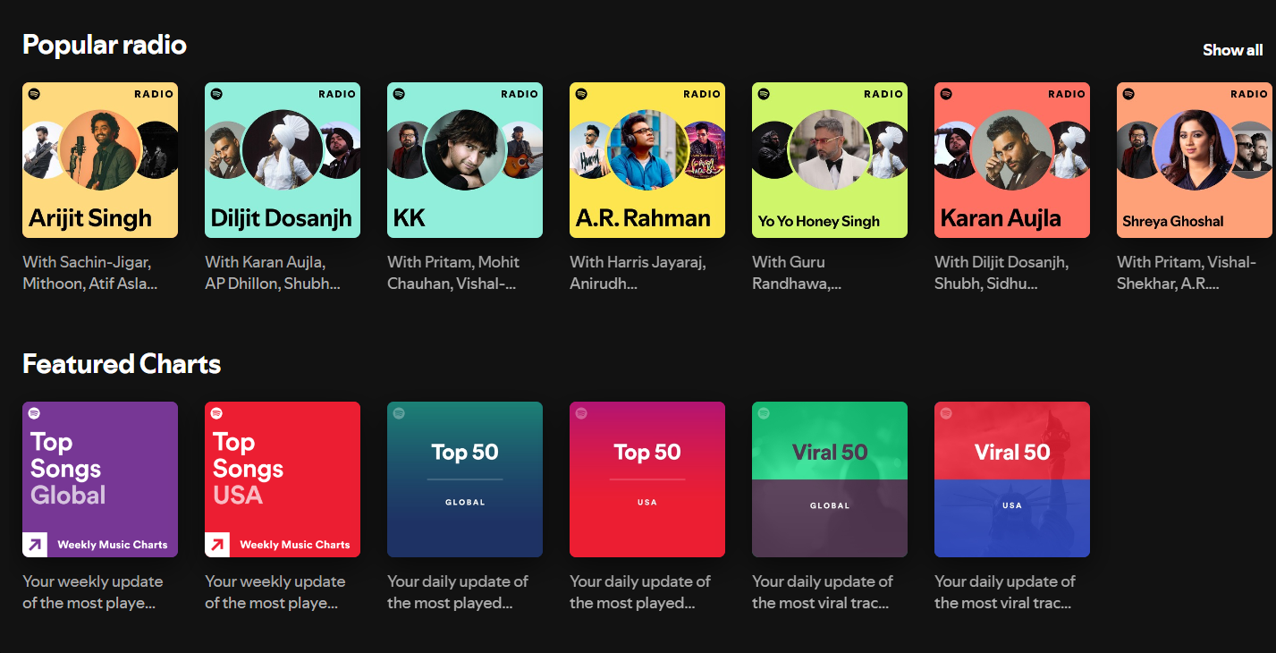

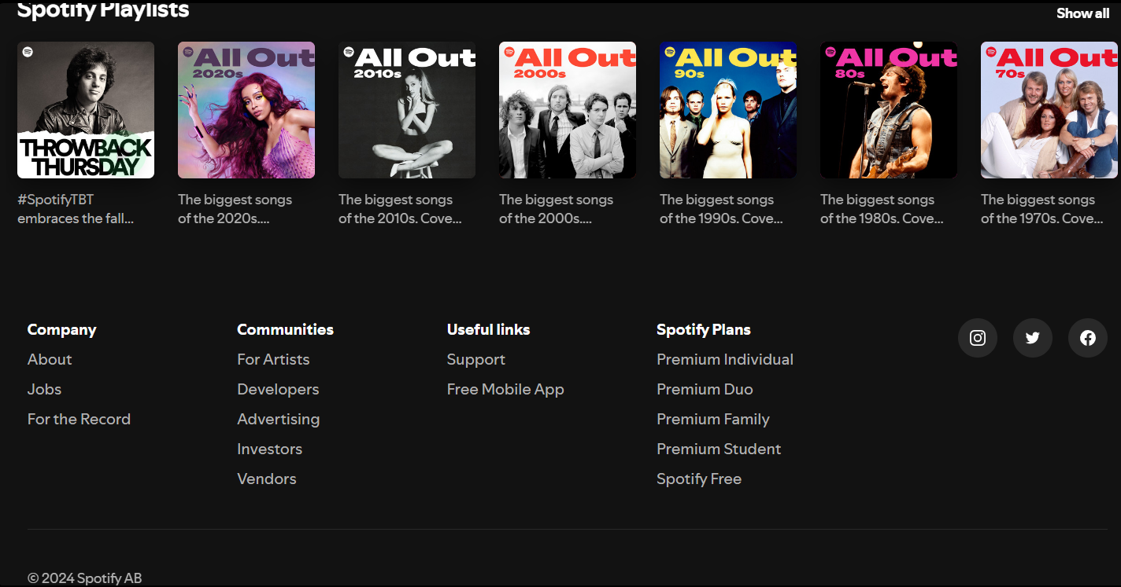

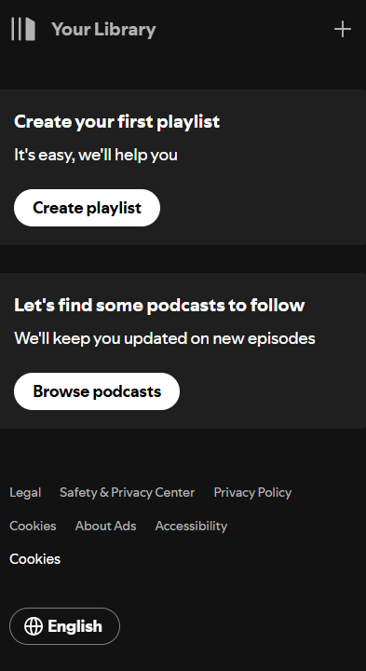

**SPOTIFY-WEB-PLAYER –DESIGNING –OPTIONS**

